# **A PROJECT REPORT ON**

**BITCOIN PRICE PREDICTION USING MACHINE LEARNING**

***Major project submitted in partial fulfillment to of the requirements for the*** ***award of the degree of***

BACHELOR OF TECHNOLOGY

IN

INFORMATION TECHNOLOGY

(2018 - 2022)

BY

D. Karthik 18241A1275

N. Sai Sujith 18241A1298

J. Ganesh 18241A1282

G. Lokesh Reddy 18241A1281

V. Sharath 18241A12B7

***Under the Esteemed guidance of***

**Deepika Borgaonkar**

**Asst Prof**, **Dept of IT**





**DEPARTMENT OF INFORMATION TECHNOLOGY**

**GOKARAJU RANGARAJU INSTITUTE OF ENGINEERING AND TECHNOLOGY**

**(AUTONOMOUS)**

**HYDERABAD**



**CERTIFICATE**

This is to certify that it is a bonafide record of Mini Project work entitled **“BITCOIN PRICE PREDICTION USING MACHINE LEARNING”** done by **D. Karthik (18241A1275), N. Sai Sujith (18241A1298), J. Ganesh (18241A1282), G. Lokesh Reddy (18241A1281)** and **V. Sharath (18241A12B7)** students of **B.Tech (IT)** in the Department of Information Technology, Gokaraju Rangaraju Institute of Engineering and Technology during the period 2018-2022 in the partial fulfillment of the requirements for the award of the degree of **BACHELOR OF TECHNOLOGY IN INFORMATION TECHNOLOGY** from GRIET, Hyderabad.

**Deepika Borgaonkar Dr. N. Ganapathi Raju** (Internal Project Guide) (Head of the Department)

(Project External)

# **ACKNOWLEDGEMENT**

We take immense pleasure in expressing gratitude to our Internal guide **Deepika Borgaonkar, Asst Prof,** Information Technology, GRIET. We express our sincere thanks for his encouragement, suggestions, and support, which provided the impetus and paved the way for the successful completion of the project work.

We wish to express our gratitude to **Dr. N. Ganapathi Raju,** our Project Co-coordinators **Mr. G. Vijender Reddy** and **K. Archana** for their constant support during the project.

We express our sincere thanks to **Dr. Jandhyala N Murthy,** Director, GRIET**,** and **Dr. J. Praveen,** Principal, GRIET**,** for providing us a conducive environment for carrying through our academic schedules and project with ease.

We also take this opportunity to convey our sincere thanks to the teaching and non-teaching staff of GRIET College, Hyderabad.

 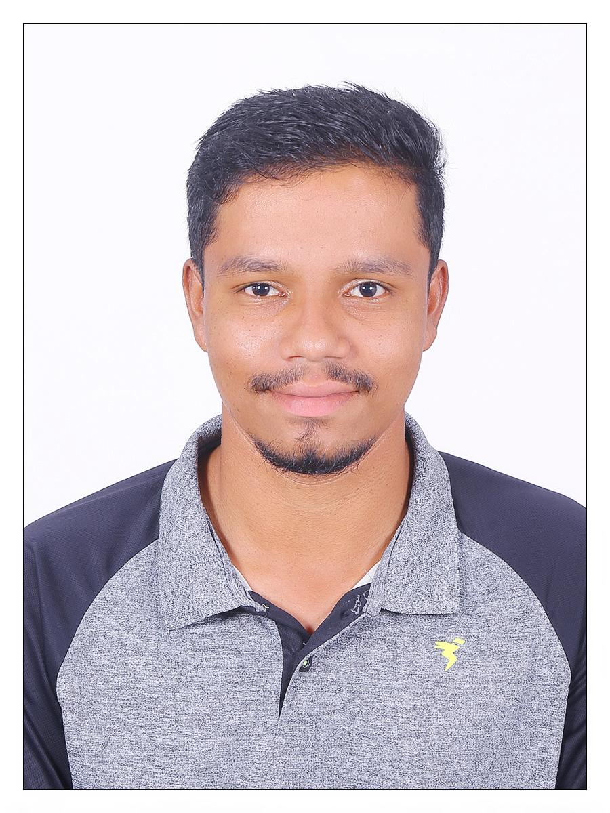

Email: dvskarthik0824@gmail.com Email: sharathmithun@gmail.com

Contact: 7981430282 Contact: 9381415799

Address: KPHB, Hyderabad. Address: Mancherial, Hyderabad

 

Email: sujithnams@gmail.com Email: jaini.ganesh@gmail.com

Contact: 8639009951 Contact: 6303001165

Address: Vivekananda Nagar, Hyderabad. Address: Reddy colony, Miryalguda.



Email: lokeshgundapureddy2001@gmail.com

Contact: 8374885876

Address: Deepthisri Nagar, Hyderabad.

**DECLARATION**

This is to certify that the project entitled “**BITCOIN PRICE PREDICTION USING MACHINE LEARNING”** is a bonafide work done by us in partial fulfillment of the requirements for the award of the degree **BACHELOR OF TECHNOLOGY IN INFORMATION TECHNOLOGY** from Gokaraju Rangaraju Institute of Engineering and Technology, Hyderabad.

We also declare that this project is a result of our own effort and has not been copied or imitated from any source. Citations from any websites, books, and paper publications are mentioned in the Bibliography.

This work was not submitted earlier at any other University or Institute for the award of any degree.

***D. Karthik 18241A1275***

***N. Sai Sujith 18241A1298***

***J. Ganesh 18241A1282***

***G. Lokesh Reddy 18241A1281***

***V. Sharath 18241A12B7***

**TABLE OF CONTENTS**

| **S. No.** | **Chapter Name** | **Page No.** |
| --- | --- | --- |
|  | Certificates | 2 |
|  | Acknowledgment | 3-4 |
|  | Declaration | 5 |
|  | Abstract | 8 |
| 1 | Introduction | 9-12 |
|  | 1.1 Machine Learning | 9-11 |
|  | 1.2 Existing System | 12 |
|  | 1.3 Proposed System | 12 |
| 2 | Requirement Engineering | 12-13 |
|  | 2.1 Hardware Module | 13 |
|  | 2.2 User Module | 13 |
|  | 2.3 Software Module | 14 |
| 3 | Literature of Survey | 15-17 |
|  | 3.1 Cryptography | 15 |
|  | 3.2 Bitcoin | 15-16 |
|  | 3.3 Python | 16 |
|  | 3.4 Jupyter Notebook | 17 |
| 4 | Technology | 18-22 |
|  | 4.1 Python Libraries | 18-22 |
| 5 | Architecture | 23-29 |
|  | 5.1 Forecasting Model | 23 |
|  | 5.2 Historic Model | 24 |
|  | 5.3 HTML Prediction | 24-25 |
|  | 5.4 Use Case Diagram | 26 |
|  | 5.5 Activity Diagram | 27 |
|  | 5.6 Communication Diagram | 28 |
|  | 5.7 Sequence Diagram | 29 |
| 6 | Implementation and Coding | 30-37 |
| 7 | Advantages and Disadvantages | 38-41 |
|  | 7.1 Advantages of Bitcoin | 38-39 |
|  | 7.2 Disadvantages of Bitcoin | 40-41 |
| 8 | Results | 42-43 |
| 9 | Conclusion and Future Enhancement | 44 |
|  | 9.1 Conclusion | 44 |
|  | 9.2 Future Enhancement | 44 |
| 10 | Bibliography | 45 |

**ABSTRACT**

The main objective of this project is to build a predictive model which predicts the value of Bitcoin using the training data set given by the user. The value of bitcoin has been altered post covid as the connections and ties from the easternmost countries are severed to a large extent.

The project is implemented upon training the machine by giving the statistical data of bitcoin to make the machine understand the basic structure of the growth of its value and estimating the ranges pre and post covid which helps in predicting the hike in the value of bitcoin.

The prediction can be done up to a certain range which can also last up to a year. So, plotting the prediction helps the user visually to compare the growth of the price of Bitcoin.

1. **INTRODUCTION**

**1.1 Machine Learning:**

The term Machine Learning was coined by Arthur Samuel in 1959, an American pioneer in the field of computer gaming and artificial intelligence, and stated that “it gives computers the ability to learn without being explicitly programmed”. ML is one of the most exciting technologies that one would have ever come across. As it is evident from the name, it gives the computer that makes it more similar to humans: The ability to learn. Machine learning is actively being used today, perhaps in many more places than one would expect. Machine learning is an application of artificial intelligence (AI) that provides systems the ability to automatically learn and improve from experience without beginning to be explicitly programmed. Machine learning focuses on the development of computer programs that can access data and use it to learn from themselves.

**Working of a Machine Learning Model**

A Machine Learning system learns from historical data, builds the prediction models, and whenever it receives new data, predicts the output for it. The accuracy of the predicted output depends upon the amount of data, as the huge amount of data helps to build a better model which predicts the output more accurately. Suppose we have a complex problem, where we need to perform some predictions, so instead of writing a code for it we just need to feed the data to generic algorithms, and with the help of these algorithms, The machine builds the logic as per the data and predicts the output. Machine learning has changed our way of thinking about the problem, Block diagram of the machine learning algorithm is as follows

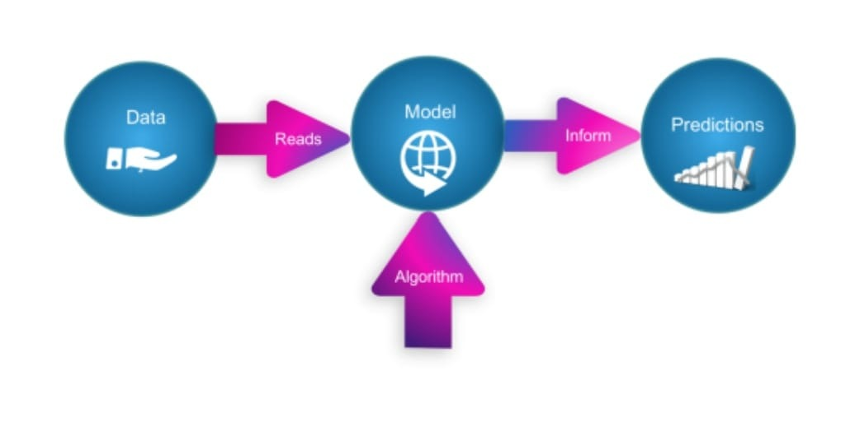

**Fig Machine Learning**

**Types of Machine Learning:**

Machine learning implementations are classified into three major categories.

1. Supervised learning
2. Unsupervised learning
3. Reinforcement learning
4. Semi-supervised learning

**1. Supervised learning:** When an algorithm learns from example data and associated target responses that can consist of numeric values or string labels, such as classes or tags, in order to later predict the correct response when posed with new examples comes under the category of Supervised learning.

**2. Unsupervised learning**: Whereas when an algorithm learns from plain examples without any associated response, leaving to the algorithm to determine the data patterns on its own. This type of algorithm tends to restructure the data into something else, such as new features that may represent a class or a new series of un-correlated values. They are quite useful in providing humans with insights into the meaning of data and new useful inputs to supervised machine learning algorithms.

**3. Reinforcement learning:** When you present the algorithm with examples that lack labels, as in unsupervised learning. However, you can accompany an example with positive or negative feedback according to the solution the algorithm proposes comes under the category of Reinforcement learning, which is connected to applications for which the algorithm must make decisions (so the product is prescriptive, not just descriptive, as in unsupervised learning), and the decisions bear consequences. In the human world, it is just like learning by trial and error.

**4. Semi-supervised learning:** Where an incomplete training signal is given: a training set with some (often many) of the target outputs missing. There is a special case of this principle known as Transduction where the entire set of problem instances is known at learning time, except that part of the targets are missing.

**Categorizing based on required Output:**

**1. Classification:** When inputs are divided into two or more classes, and the learner must produce a model that assigns unseen inputs to one or more (multi-label classification) of these classes.

**2. Regression:** This is also a supervised problem, A case when the outputs are continuous rather than discrete.

**3. Clustering:** When a set of inputs is to be divided into groups. Unlike in classification, the groups are not known beforehand, making this typically an unsupervised task

**1.2 EXISTING SYSTEM**

Bitcoin price predictors have a range of a week.

At maximum they provide a free trial of three to four uses and the sites ask for either log in through mail or make it paid for the further uses.

**1.3 PROPOSED SYSTEM**

The advantage of the proposed system is that it is very efficient as the data is being predicted for long and also for free of cost where the accuracy levels are more and the range is very high compared to other online free predictors.

**2. REQUIREMENT ENGINEERING**

* **2.1 HARDWARE MODULE**

A laptop or Desktop with minimum requirements of 8 GB RAM and an operating system like windows/ios/Linux. And also supports all virtual machines and all programming IDE’S. Some other specifications like A CPU that has an Intel processor or better and A solid-state drive(SSD) of 256 GB or more.

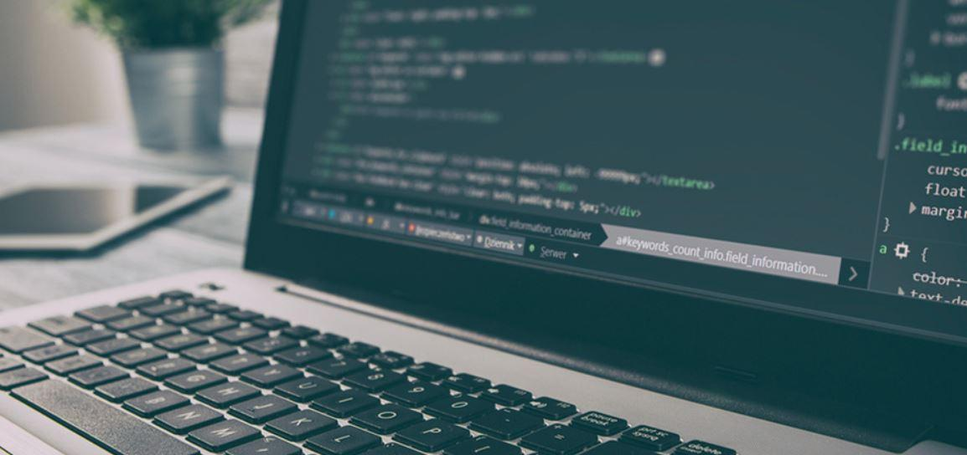

**Fig 1 Hardware module**

* **2.2 USER MODULE**

In the User module, we have user input consisting of previous data which is used to give the model to check the growth of the price. It is nothing but user input consists of some previous data that is used to give to the model and with that input model will predict the price.

**2.3 SOFTWARE MODULE**

**2.3.1 JUPYTER**

Jupyter Notebook is open-source web software that lets you create and share documents with live code, equations, visualizations, and narrative text. Data cleansing and transformation, numerical simulation, statistical modeling, data visualization, machine learning, and many other applications are all possible.

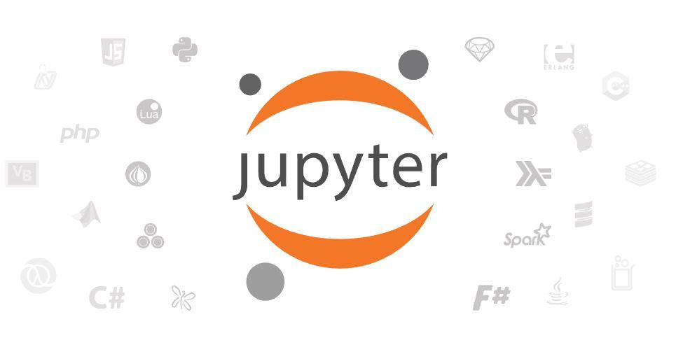

**Fig 2 Jupyter**

We have used jupyter IDE for our code execution. Jupyter IDE supports all the python libraries which are needed for our project.

**3. LITERATURE OF SURVEY**

**3.1 Cryptography:**

Cryptographic money, regularly known as digital currency or crypto, is an assortment of twofold information utilized as a vehicle of trade. Individual cash possession records are kept in a record, which is an advanced information base that utilizes solid cryptography to get exchange records, control coin creation, and confirm proprietorship transfers. Because digital money is neither upheld by nor convertible into an item, it is named a fiat currency. Validators are utilized in a few crypto plans to keep the digital money running. Proprietors of tokens set up their tokens as guarantees in a proof-of-stake plan. In return, they deal with the token concerning their stake. Token stakers commonly gain expanded proprietorship in the token over the long run because of organization expenses, newly made tokens, or other remuneration systems. Digital currency doesn't exist in actual structure (like paper cash) and is commonly not given by a focal power.

**3.2 Bitcoin:**

The Bitcoin logo has passed through two crypto enthusiasts Satoshi and Bitboy. The Brainchild of Bitcoin, Satoshi Nakamoto crafted the first logo in 2008. Bitcoin is a digital currency, without a central bank or admin which can be shared between user to user on the bitcoin network. All the transactions are noted by a public ledger and copies are held across the world on the servers. These servers, known as nodes, can be set up by anyone with a spare computer. Whoever owns the coins is reached cryptographically across these nodes without relying on any central source of trust.

On 18 August 2008, the domain name bitcoin.org was registered. Later, on Oct 31 Satoshi Nakamoto titled “Bitcoin: A Peer-to-Peer Electronic Cash System”. On 3rd January 2009, Satoshi Nakamoto created the Bitcoin network by mining the genesis block of bitcoin. The first transaction happened on 22nd May 2010, by transacting 10,000 BTC in exchange for two pizzas.

**Value of Bitcoin (in terms of US dollar)**

1. Bitcoin price was less than $0.01 US dollar in May 2010.
2. Bitcoin price matches that of $1 US dollar in February 2011.
3. Bitcoin price reached $5,000 US dollars in September 2017.
4. Bitcoin price reached $50,000 US dollars in February 2021.
5. Bitcoin price reached $68,789 US dollar in November 2021 which is currently the all-time high value.
6. As of today, Bitcoin’s price is around $54,333 US dollars.

**3.3 Python:**

Python is a programming language that can be understood by both humans and machines. Guido Van Rossum, a Dutch software developer, invented it in the early 1980s and released it in 1991 to help programmers write clear, logical code for general-purpose programming at small and big scales.

Python is an interpreted high-level programming language that can be used to create programs that are structured, procedural, functional, imperative, reflective, or object-oriented.

Python, a dynamically typed language, is gaining traction in the technology industry thanks to its simple programming syntax, code readability, English-like commands, and versatility in a well-organized structure. It is more efficient and straightforward to learn than other programming languages. As a result, Python is the greatest option for a wide range of jobs, from a simple web application to a whole operating system.

**What is Python used for?**

The most important advantage of Python is that it's a general-purpose language that can be applied in many varieties of fields. The most common domains where Python is applied are as follows:

1. Data science
2. Artificial intelligence and Machine learning
3. Web development
4. Software development
5. Scientific and numeric applications
6. Game development
7. Graphic design Applications
8. Operating systems
9. Desktop GUI

**3.4 Jupyter Notebook:**

The IPython Notebook is now known as the Jupyter Notebook. It is an interactive computational environment, in which you can combine code execution, rich text, mathematics, plots, and rich media. The notebook extends the console-based approach to interactive computing in a qualitatively new direction, providing a web-based application suitable for capturing the whole computation process: developing, documenting, and executing code, as well as communicating the results.

The IPython notebook combines two components:

1. **Web application:** a browser-based tool for interactive authoring of documents that combine explanatory text, mathematics, computations, and their rich media output.
2. **Notebook documents**: a representation of all content visible in the web application, including inputs and outputs of the computations, explanatory text, mathematics, images, and rich media representations of objects.

**4. TECHNOLOGY**

**4.1 PYTHON LIBRARIES**

The following libraries are used in our code

1. YFINANCE
2. PANDAS
3. FBPROPHET
4. MATLPLOTLIB
5. DATETIME
6. **YFINANCE**

yfinance is a well-known open-source library created by Ran Aroussi to access the financial data on Yahoo Finance. Yahoo Finance has a wealth of market information on stocks, bonds, currencies, and cryptocurrencies. It also provides market news, research, and analysis, as well as options and fundamentals data, which distinguishes it from its competitors.

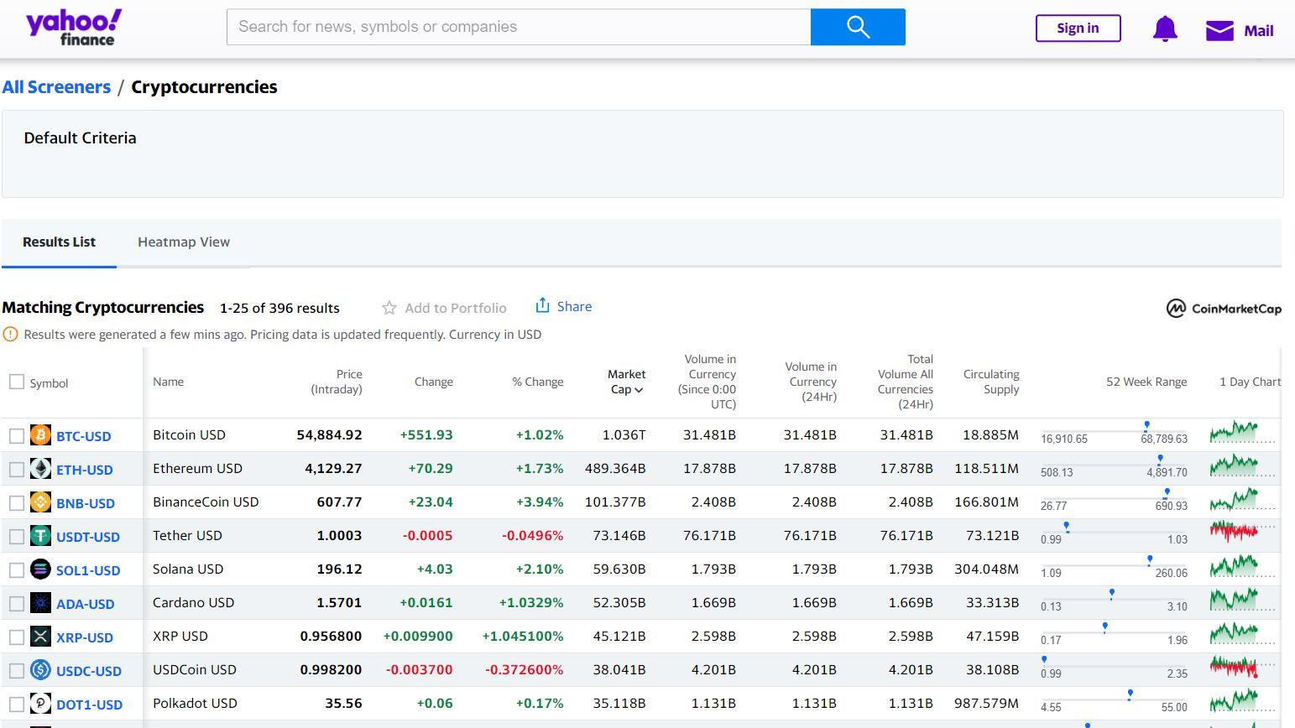

**Fig 3 Yfinance**

yfinance library was originally named yahoo_finance and for the purposes of compatibility, it was remanded to its shorter version.

yfinance functions as a link between the Python environment and the user's historical data, making it easier to import.

Real-time data will be imported into the workspace along with the previous data which will be useful for the user to predict future values

yfinance provides a pandas data frame with numerous columns representing the user's past values.

**2. PANDAS**

Pandas is a Python package that allows you to work with large data sets. It offers tools for data analysis, cleansing, exploration, and manipulation. Wes McKinney came up with the name "Pandas" in 2008, which refers to both "Panel Data" and "Python Data Analysis." Pandas make it possible to evaluate large amounts of data and provide conclusions based on statistical theory. Pandas can clean up and produce readable and useful data collections.



**Fig 4 Pandas**

Python is an open-source programming language. It's difficult to know which package is ideal for a certain task. For data science, there is one package that we definitely must learn: pandas. Although the strong machine learning and attractive visualization capabilities may have piqued your interest, you won't get very far if you don't know how to use Pandas.

Pandas have two basic data structures: **Series** and **Dataframes**. Dataframes are the most common way to store data, so handling them fast is perhaps the most critical skill set for data analysis.

The output format of pandas can be visualized using matplotlib and NumPy. pandas primarily have data structures and operations that can be done on numerical tables and temporal series. pandas have various methods that can be used to speed up the calculating process of analyzing the data.

**3. FBPROPHET**

Prophet is [open-source software](https://code.facebook.com/projects/) released by Facebook’s [Core Data Science team](https://research.fb.com/category/data-science/). The prophet is a time-series data forecasting process based on an additive model that fits non-linear trends with yearly, weekly, and daily seasonality, as well as holiday impacts. It works best with time series with substantial seasonal influences and historical data from multiple seasons. Prophet is forgiving of missing data and trend shifts, and it usually handles outliers well.

**Fig 5 Prophet**

fbprophet is a library that is used to forecast data in a nonlinear fashion. It includes a method called prophet that handles all trend shifts and outliers in historical data. Prophet requires a data frame in a certain format with "ds" and "y" as column names to access the information. So generally with this fbprophet package, we can forecast the given data. So by using this package we can give the data like historic prices of bitcoin and forecast the future prices of bitcoin.

**4. MATPLOTLIB**

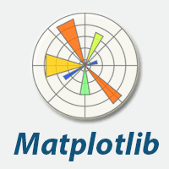

**Fig 6 Matplotlib**

Matplotlib is a fantastic Python visualization package for 2D array charts. Matplotlib is a multi-platform data visualization package based on NumPy arrays and intended to operate with the SciPy stack as a whole. It was first introduced in 2002 by John Hunter.

One of the most significant advantages of visualization is that it provides us with visual access to massive volumes of data in simply understandable graphics. Matplotlib has a variety of plots such as line, bar, scatter, histogram, and so on.

Many of matplotlib's operations are contained in the pyplot submodule. It is used to plot the graph for the information provided by the user. We can add specific details to the plot by labeling the axes according to the user's requirements. We can also use matplotlib to evaluate trends by providing scatter plots to verify the crests and troughs in the trends.

**5. DATETIME**

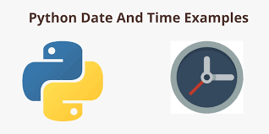

**Fig 7 DateTime**

Although date and time aren't data types in Python, a module called datetime can be imported to work with both the date and the time. There is no need to install the Python Datetime module outside because it is included in Python.

The Python Datetime package provides classes for manipulating dates and times. These classes offer a variety of capabilities for working with dates, times, and time intervals. In Python, date and datetime are objects, so when you manipulate them, you're altering objects rather than strings or timestamps.

The advantage of datetime is that it is unchangeable (immutable), and these values may also be used as dictionary keys to store and update values for it dynamically. time and datetime have abundant information, which uses optimal time-zone information to provide accurate data to the workspace.

**5. ARCHITECTURE**

The architecture of the Bitcoin prediction project consists of three sections. They are:

1. Forecasting model
2. Historic price
3. HTML prediction

**5.1 Forecasting model:**

The forecasting model of the project ensures that the data from the cloud is extracted and brought to the timeline of the project to predict the price values up to a certain date required by the user. The trend of a specific cryptocurrency is estimated to a certain range of days given by the user as input. Referring to this model has an advantage as we do not take any data from the user or do not request any kind of payment to use to retrieve the information from the model.

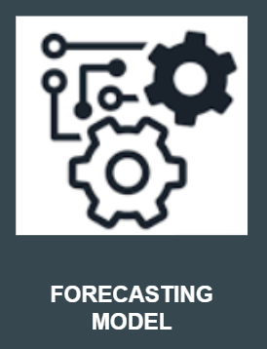

**Fig 8 Forecasting Model**

**5.2 Historic price:**

The previous years’ data of the BItcoin will be imported to the model using the yahoo finance website which has all the price values of the cryptocurrency from its origin. As Bitcoin was started to grow rapidly in the early ’20s, the data also was digitalized from the same year i.e 2014 in this case. The evolution of e-cash was begun during the late 20th century which has taken a significant hike as it can reduce the usage of paper notes and can also decrease the flow of black money in the states. The initial storage of online cash does not have any security but later as the clients increased, the storage of online cash was also introduced with an encrypted system called Blockchain technology.

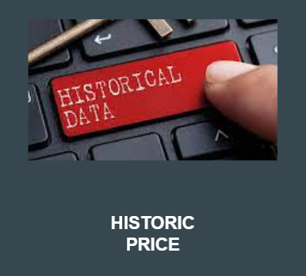

**Fig 9 Historic price**

**5.3 HTML Prediction:**

After the data is collected to the model from the cloud, the model starts to predict the future prices of Bitcoin for the certain number of days given by the user and plots a graph that gives information about the present price ranges of Bitcoin from the beginning and predicts a certain number of days ahead given by the user and shows it on the web page. The predicted price is not exactly the same as the real-time values as the yfinance has a delay of 15 minutes to the real-time scenario.

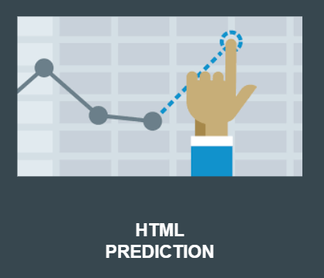

**Fig 10 HTML Prediction**

**5.4 Use Case Diagram**

A use case diagram in the Unified Modelling Language (UML) is a type of behavioral diagram defined by actors and created from a Use-case analysis. Its purpose is to present a graphical overview of the functionality provided by a system in terms of actors, their goals (represented as a use case), and any dependencies between those cases. The main purpose of a use case diagram is to show system functions are performed for which actor. Roles of the actors within the system are often depicted.

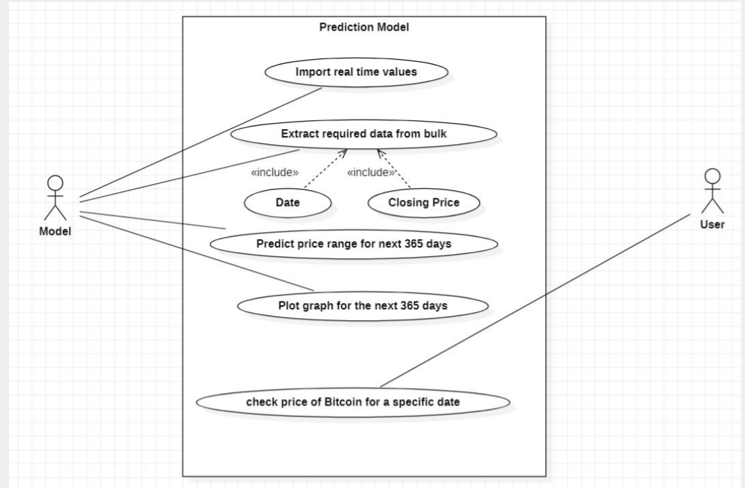

**Fig 11 Use case diagram**

**5.5 Activity Diagram**

An Activity Diagram is a type of behavioral diagram and it represents the behavior of a system. The basic components of an Activity diagram are Action, Decision Node, Control flow, Start node, and end node. An Activity diagram shows us the control flow from the starting point to the finishing point showing the various decision paths that exist while the activity is being executed. Activity diagrams are useful for business modeling where they're used for detailing the processes involved in business activities.

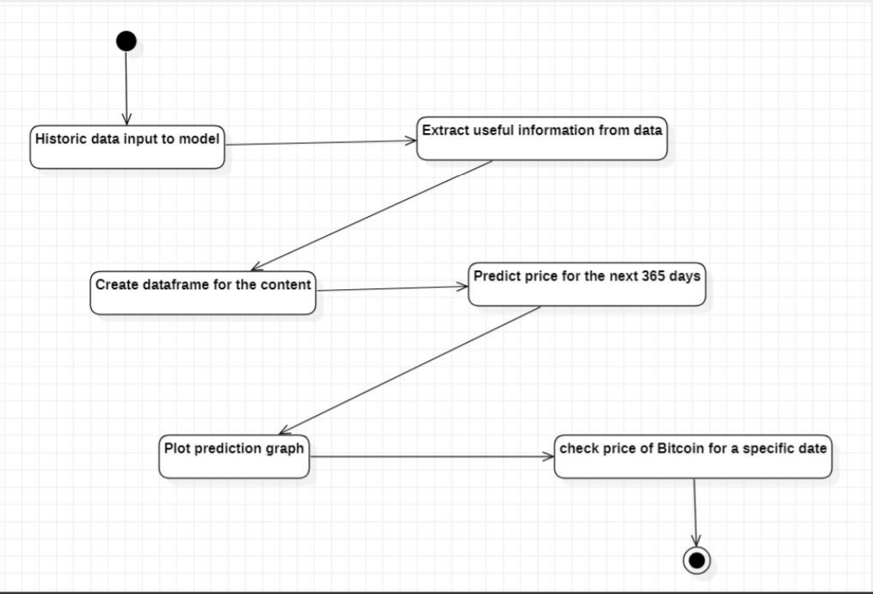

**Fig 12 Activity diagram**

**5.6 Communication Diagram**

Communication diagrams are also referred to as collaboration diagrams and these are just like sequence diagrams in UML but they focus more on the relationships of objects about how they associate and connect through messages during a sequence instead of interactions. Messages are added to the associations and shown as short arrows pointing in the direction of the message flow. The sequence of messages is shown through a numbering scheme.

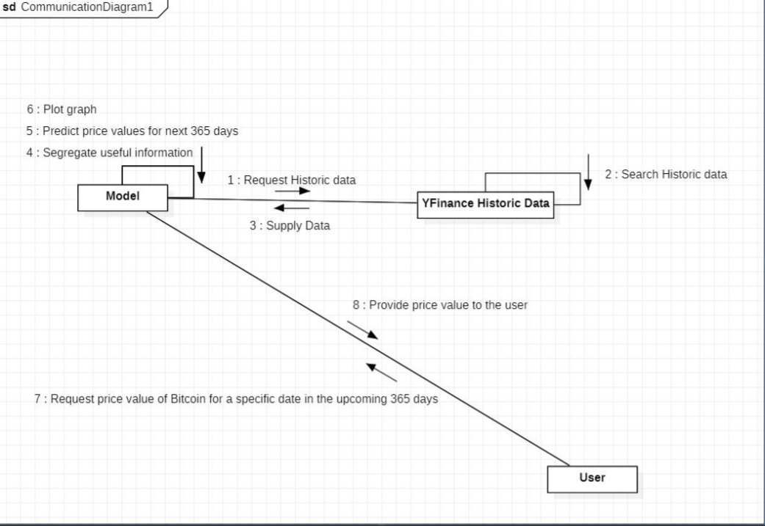

**Fig 13 Communication diagram**

**5.7 Sequence Diagram**

A sequence diagram in UML is a kind of interaction diagram which shows how each process of the system operates with one another and in what order. It is constructed as a message sequence chart. A sequence diagram shows the interaction of objects through messages which are arranged sequentially. It represents the objects involved and the sequence of messages exchanged between the objects needed to carry out the functionality. Sequence diagrams are sometimes called event diagrams or timing diagrams.

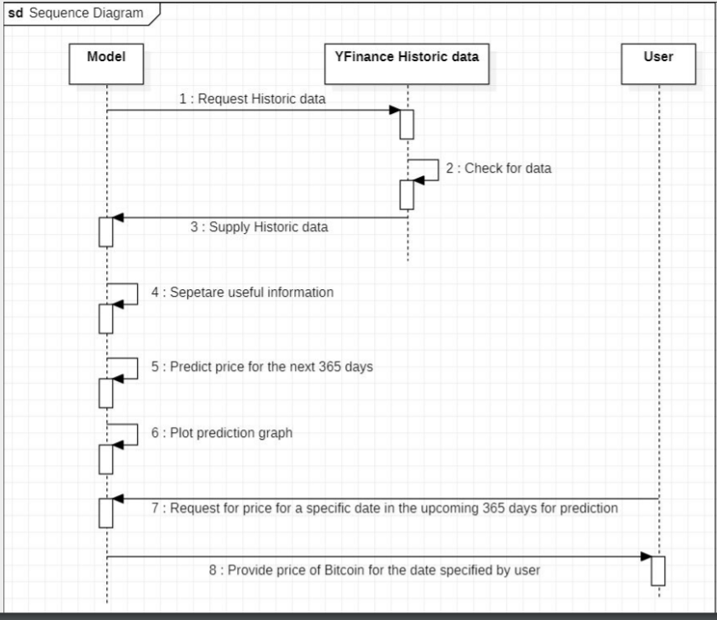

**Fig 14 Sequence diagram**

**6. IMPLEMENTATION AND CODING**

Firstly, we will import the historical data from yahoo finance and dump it into our interface using yfinance. The libraries used in this case study are yfinance, pandas, fbprophet, matplotlib.pyplot, datetime, fbprophet.plot. The dataset is named “BTC-USD” in the online platform. The previous data from the creation of the Bitcoin cryptocurrency is used as training data set to the algorithm. We collect the closing value of the coin for the day, store it in the pandas data frame and predict the price value for the upcoming year.

The format of the date is arranged according to the specifications of the user(for example date/month/year). Here we used the format year/ month/ date. A pandas data frame is created to store the values of the date along with serial numbers. The value to predict the future price values can be adjusted to the requirement of the user. The trend of the coin will be updated while giving users the values of the coin which are the lowest and highest in the day as yhat_lower and yhat_upper while storing the average in yhat. A forecast of the coin is given in the form of a graph with dimensions 15 by 10 which consists of the timeline of years as labeled on the X-axis and price levels as labeled on the Y-axis.

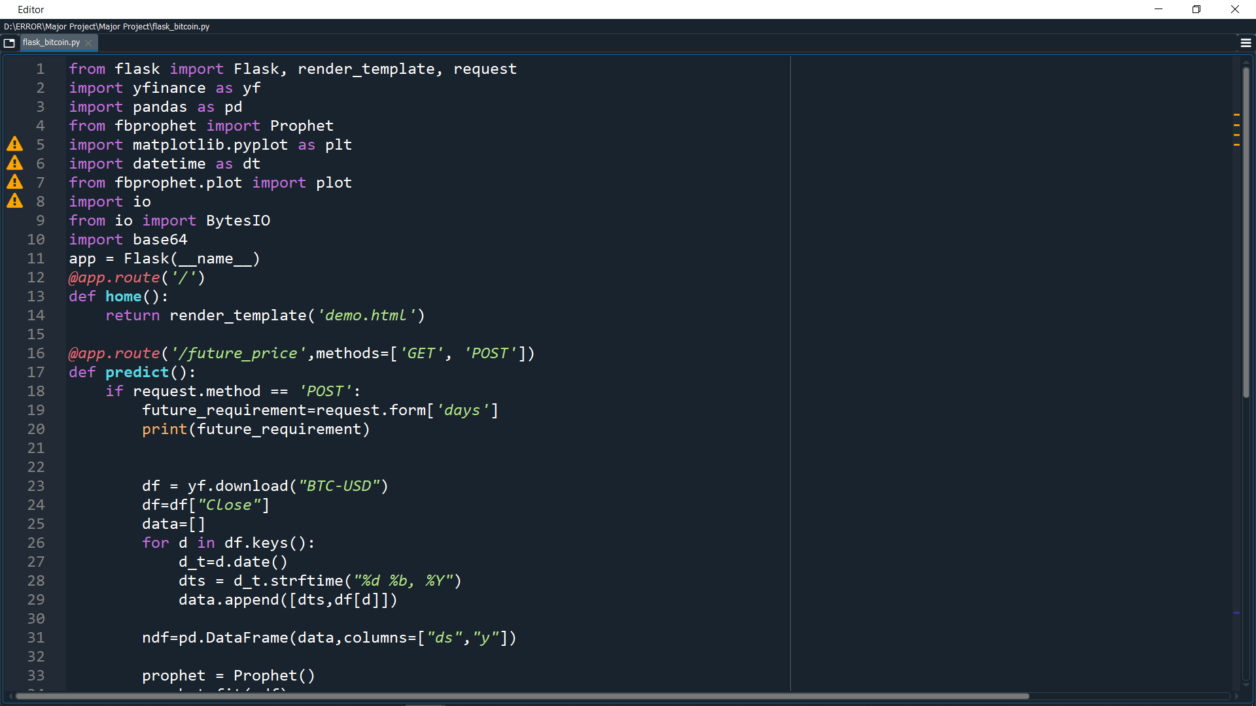

**Fig 15 Model code 1**

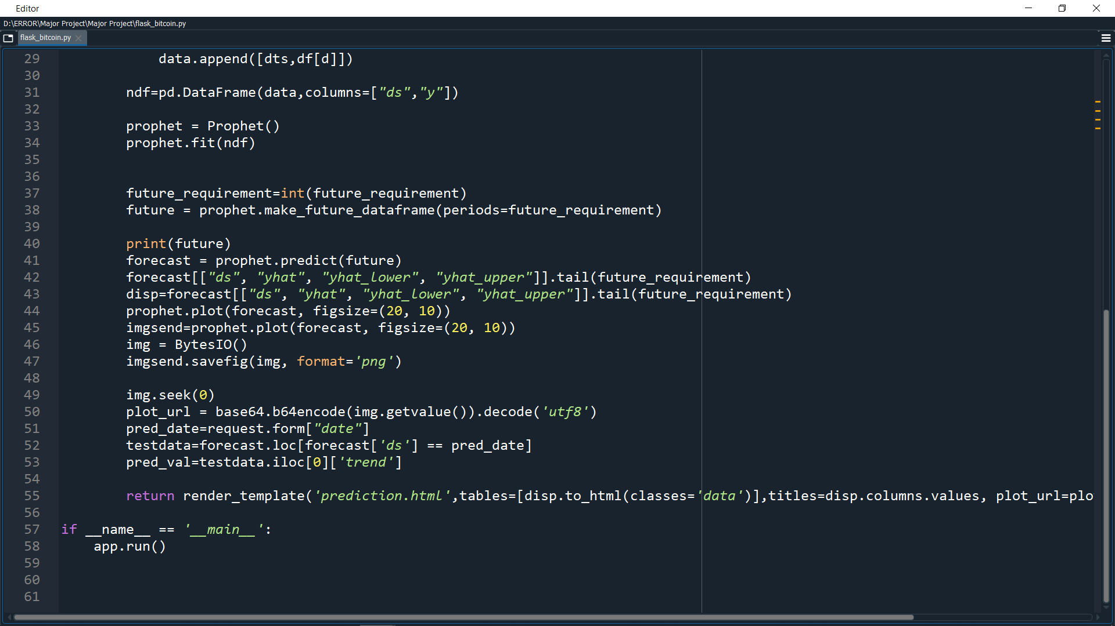

**Fig 16 Model code 2**

By running the start button, the flask linked program gives us a dynamic link to open in a webpage.

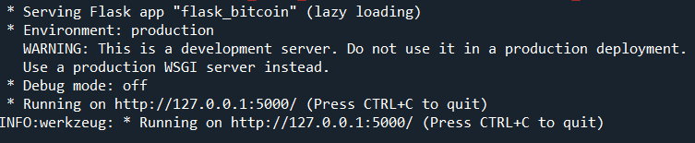

**Fig 17 Model code 3**

By copying the link onto the browser(http://127.0.0.1:5000/) gives the home page of the price prediction which has two inputs.

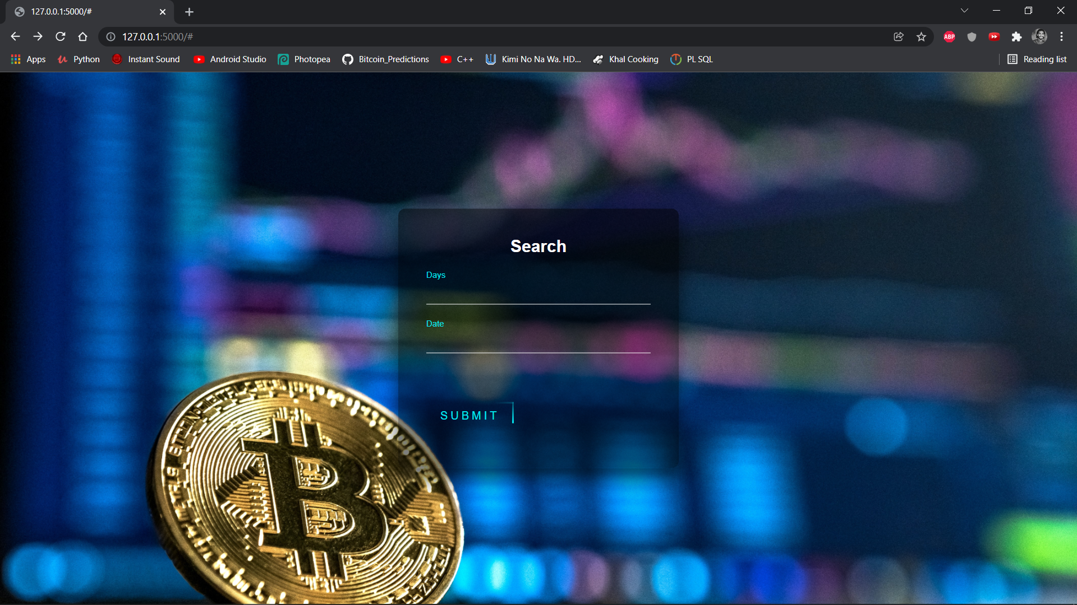

**Fig 18 Web page**

The first input is the value from the user to how many days is the requirement. The second input is the date format (YYYY/MM/DD) by the user to which date the user wants to know about the price. The submit button redirects us to the second part of the calculated predictions. This page gives the predicted values for a certain number of days and a plot graph.

The graph is a combination of a scatter plot and prediction curve. The lower and upper ranges are also marked for the understanding purposes of the limit of the price levels. This predicts the future prices of Bitcoin for the certain number of days given by the user and plots a graph that gives information about the present price ranges of Bitcoin from the beginning and predicts a certain number of days ahead given by the user. The predicted price is not exactly the same as the real-time values as the yfinance has a delay of 15 minutes to the real-time scenario.

The yhat gives the information of the predicted price levels of lower range to the upper range including average with the trends of the Bitcoin price values.

Next, a graph is plotted for the referral purposes of the user to understand the trend of the pricing levels in Bitcoin.

Later, the predicted value of the price of the cryptocurrency in US Dollars currency is shown after the graph.

The web pages were designed with basic HTML and CSS to give an interactive vibe to the user. The below is the code for the first page of the web.

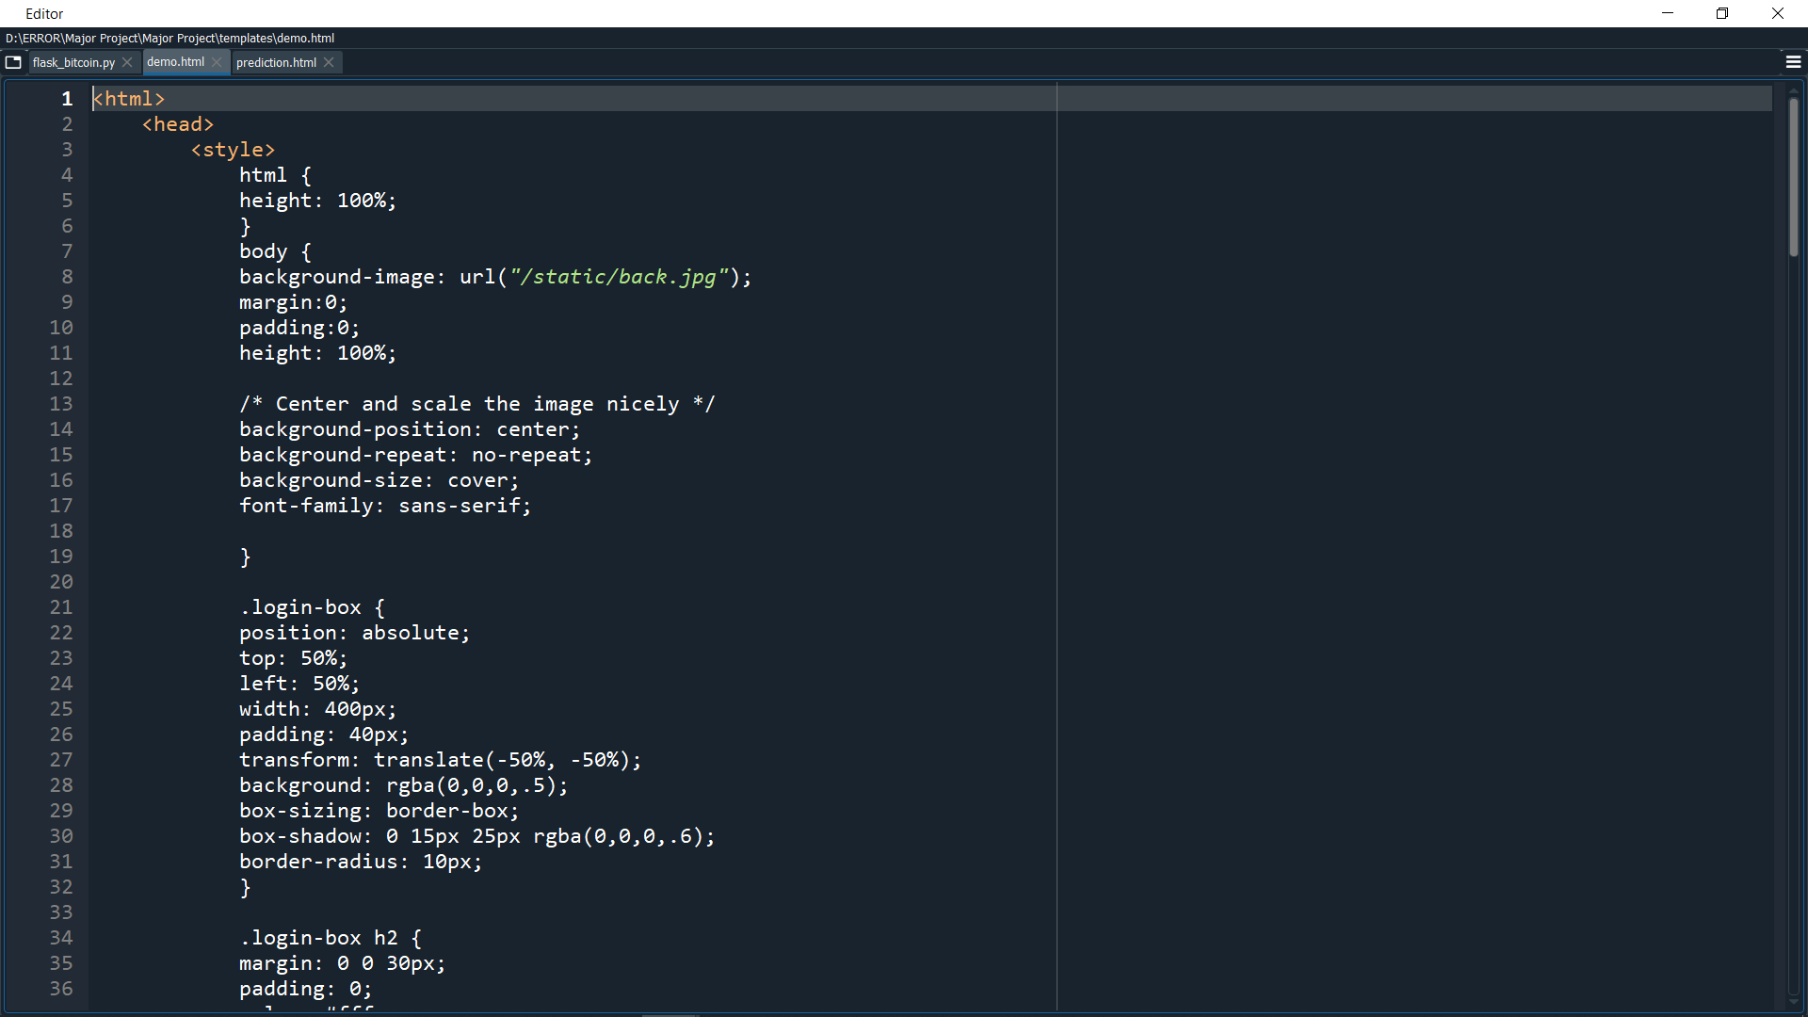

**Fig 23 HTML code 1**

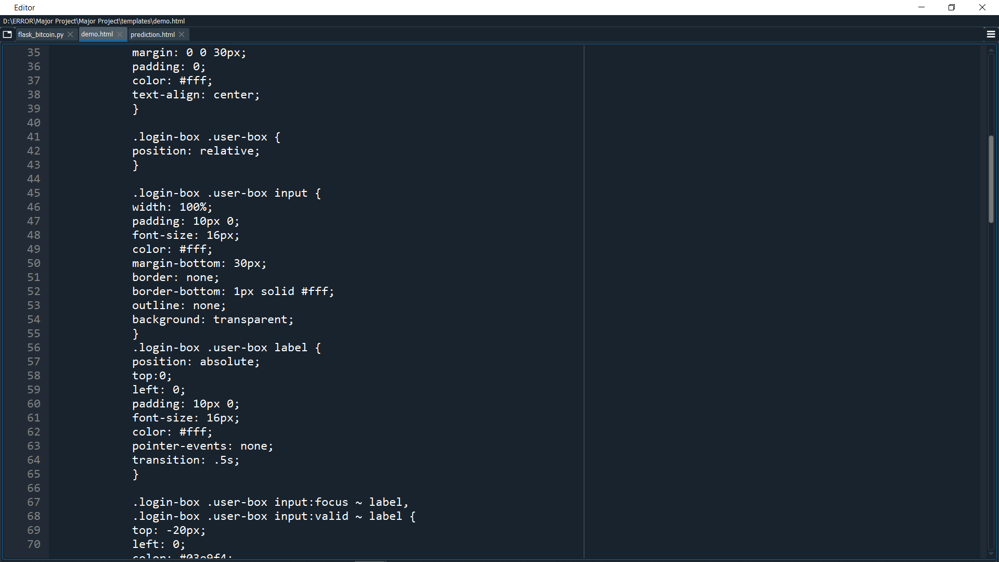

**Fig 24 HTML code 2**

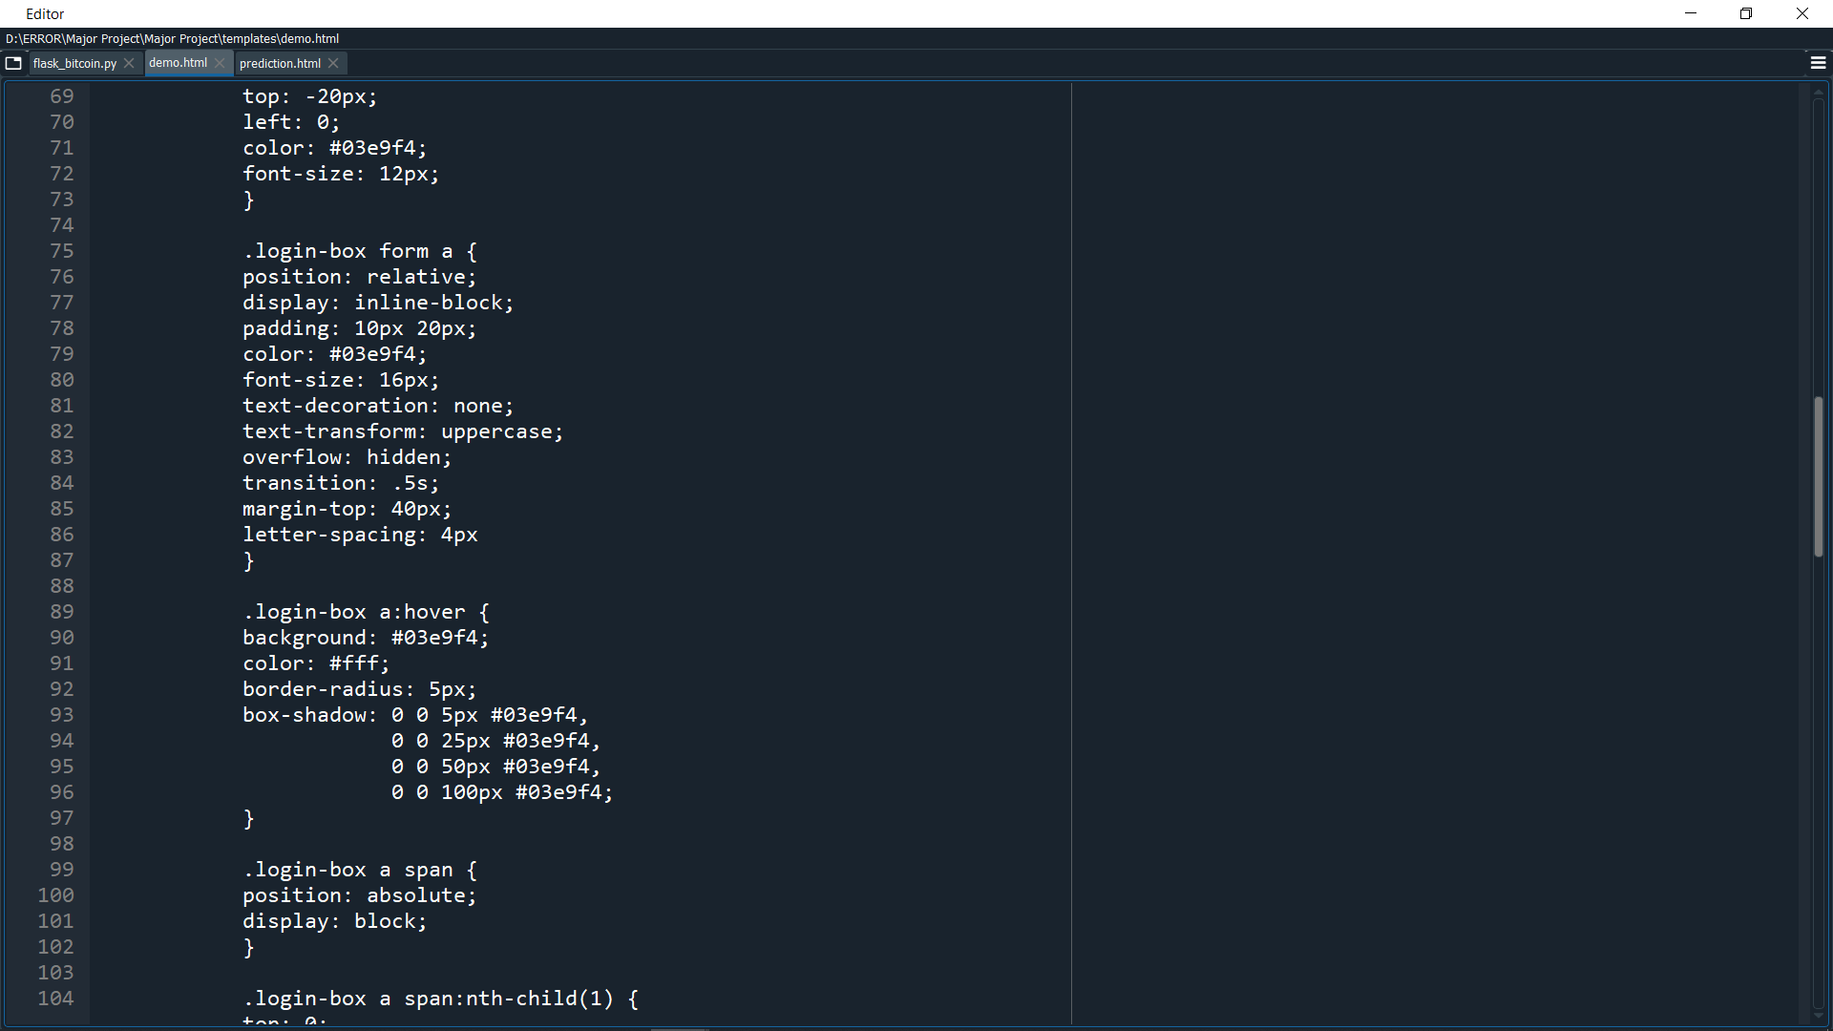

**Fig 25 HTML code 3**

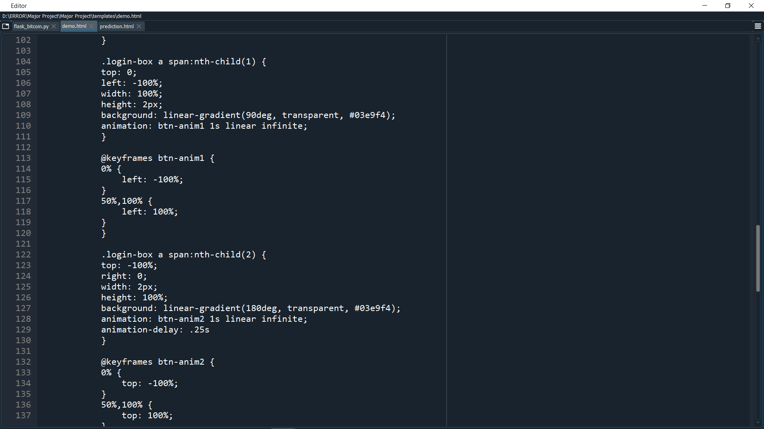

**Fig 26 HTML code 4**

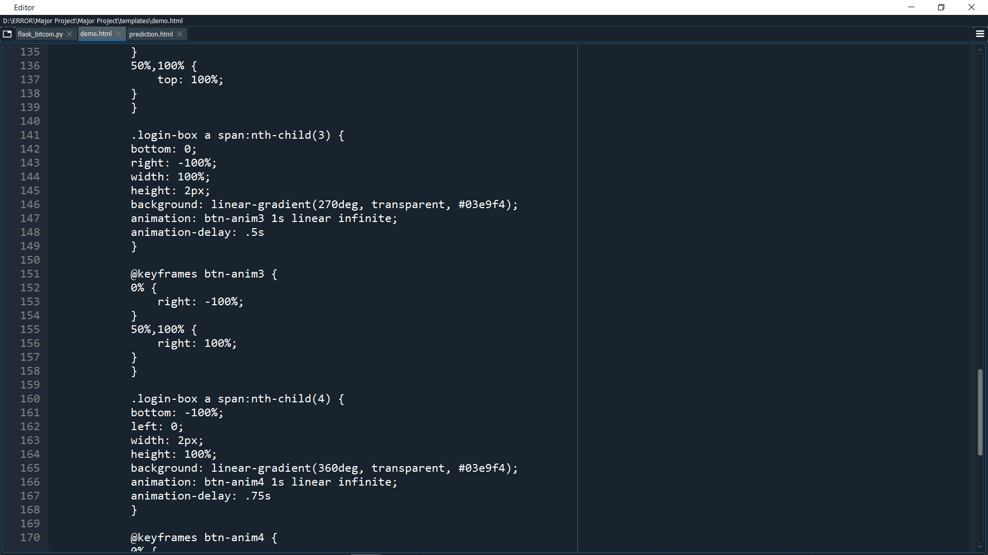

**Fig 27 HTML code 5**

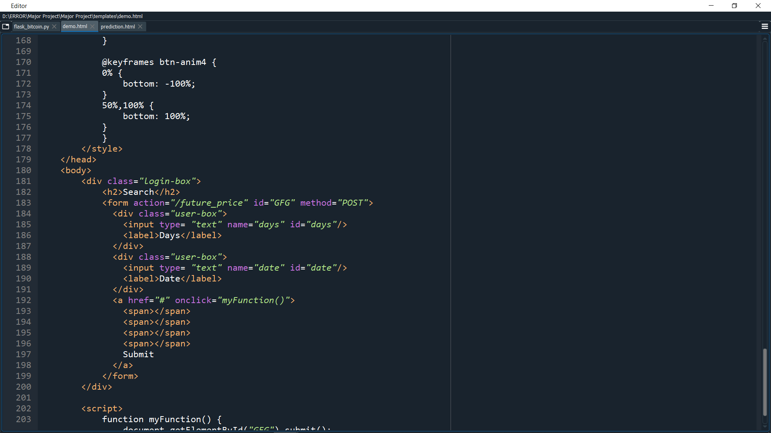

**Fig 28 HTML code 6**

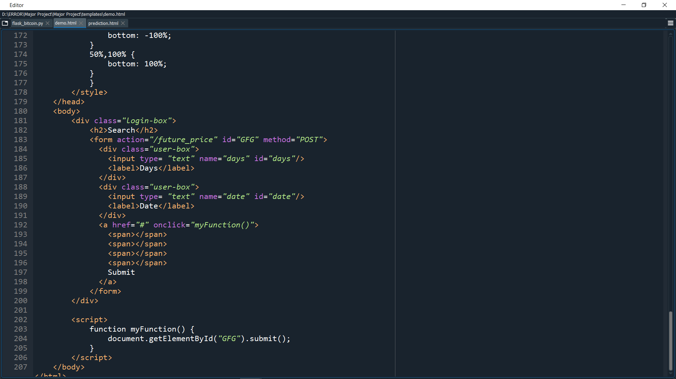

**Fig 29 HTML code 7**

The above code is the interactive code that retrieves the input by the user and uses that as input for the prediction which is shown on the second web page. The below code for the second web page is also written in HTML.

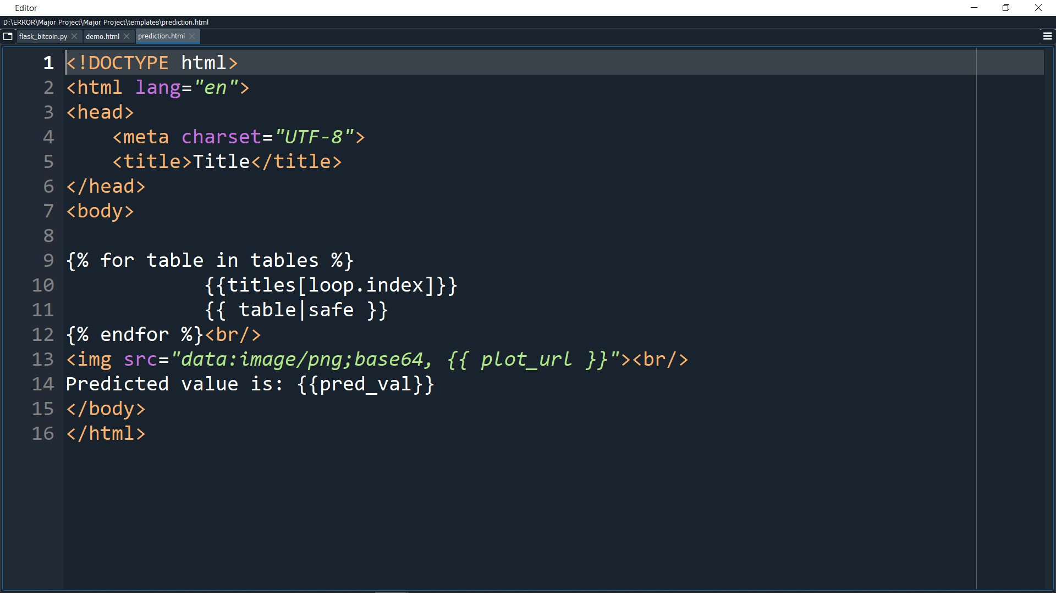

**Fig 30 HTML code 8**

The second page gives a total of three values as outputs. Firstly, a table of the price values of all the dates that are predicted by the model is shown as a tabular data frame. Next, the plot is shown from the origin to the next number of predicted dates. Lastly, the predicted output for a specific date which is taken as input from the user is shown below the graph.

**7. ADVANTAGES AND DISADVANTAGES**

**7.1 ADVANTAGES OF BITCOIN:**

**1. Lightning-Fast Transactions:**

One of the most serious issues with fiat currency is that transactions often take days, if not weeks, to complete. This is not the case. You'll get your money right away, whether it's 10 a.m. or 2 a.m.! There are no middlemen, which means less time spent waiting and less hassle. You can visit the Bitcoin Loophole webpage for further information. If you want to send BTC to a friend in another nation, all you have to do is type in his bitcoin address and send; there are no limits and this transfer cannot be reversed.

**2. Lower Transaction Fees:**

Imagine having to spend more than $35 to withdraw money from your own bank account. If you withdraw more than $1000, you may be required to pay that fee. Bitcoin transactions, on the other hand, have no fees for transfers of any value; all you pay is a tiny charge to miners (to process the transaction). Don't worry, this has been kept to a minimal minimum as well.

**3. Privacy:**

Bitcoin transactions are anonymous, making it ideal for those who value their privacy. Every BTC wallet owner has one or more public keys that serve as their bitcoin address(es), and these are the only pieces of information required to complete a transaction. Unlike the credit card system, where your name, billing address, and other information are required to execute a payment, all you have to do with bitcoin is enter the recipient's address**.**

**4. Decentralization:**

Bitcoin transactions are unaffected by governments or financial institutions due to their decentralized nature. This makes it a good choice for those who are opposed to the system or who require additional privacy. Users' information can be hijacked using typical payment systems like PayPal or credit cards, giving hackers access to their full financial records and allowing them to perform fraudulent transactions. However, due to BTC's unique blockchain technology, these issues will never arise.

**5. No Charge Backs:**

There are no chargebacks using BTC. This means that once a BTC transaction is completed, it cannot be reversed; the other party has your money while you have their product (irrespective of whether you like it or not).

**6. Bitcoin Value:**

Another reason why consumers should seriously consider dealing with Bitcoin rather than conventional currency, which might devalue without warning, is its value. Bitcoin, on the other hand, will always have the same price (determined by the free market)! This makes bitcoin a fantastic store of value, and unlike paper money, there are no restrictions on converting your BTC into other currencies. Your bitcoins are completely under your control!

**7. No Inflation:**

Traditional payment systems also have the potential to lead to inflationary pressures. Because of its decentralized structure, there are no limits on how much bitcoin may be mined, resulting in a market with a fixed supply of BTC. This means you'll never have to worry about your digital assets decreasing in value due to time because bitcoin is only restricted by the quantity of bitcoins in circulation, not by any other constraints!

**8. Bitcoin is Secure:**

Under today's environment, with cyber-attacks happening all over the world at the touch of a hacker's keyboard, the security of fiat currency is in question. When it comes to bitcoin, however, every transaction is recorded on an open distributed ledger, which means that if someone tries to make unauthorised changes, the entire BTC community will be informed! As a result, bitcoin transactions are extremely safe.

**7.2 DISADVANTAGES OF BITCOIN:**

**1. Bitcoins Are Not Widely Accepted:**

Bitcoin is still only accepted by a tiny number of internet businesses. As a result, relying solely on Bitcoins as a currency is impossible. It's also possible that governments will force retailers to stop accepting Bitcoins in order to track consumers' transactions.

**2. Wallets Can Be Lost:**

Bitcoins are effectively "lost" if a hard drive crashes or a virus corrupts data, and the wallet file is corrupted. There's nothing that can be done to get it back. These coins will remain orphaned in the system indefinitely. This has the potential to bankrupt a wealthy Bitcoin investment in a matter of seconds, with no chance of recovering. The investor's coins will be permanently orphaned as well.

**3. Bitcoin Valuation Fluctuates:**

Bitcoin's value is continually fluctuating based on demand. On June 2nd, 2011, a popular bitcoin exchange site valued one Bitcoin at $9.9. It was only 6 months ago that it was valued at less than $1. Because of the frequent fluctuation, Bitcoin accepting sites will have to adjust their prices on a regular basis. If a product refund is issued, it will also cause a lot of uncertainty. For example, if a t-shirt was purchased for 1.5 BTC and returned a week later, should 1.5 BTC be refunded despite the fact that the value has increased, or should the new amount (calculated according to the current value) be sent? When evaluating valuations, which currency should BTC be pegged to? These are still fundamental concerns about which the Bitcoin community is divided.

**4. No Buyer Protection:**

When products are purchased using Bitcoins and the seller fails to deliver the goods, there is no way to reverse the transaction. This difficulty can be handled by employing a third-party escrow service such as Clear Coin, however escrow services would then take on the function of banks, making Bitcoins more like traditional currencies.

**5. Risk of Unknown Technical Flaws:**

When products are purchased using Bitcoins and the seller fails to deliver the goods, there is no way to reverse the transaction. This difficulty can be handled by employing a third-party escrow service such as Clear Coin, however escrow services would then take on the function of banks, making Bitcoins more like traditional currencies.

**6. Built in Deflation:**

Built-in Deflation: Because the total amount of bitcoins is limited to 21 million, deflation will occur. As the overall number of Bitcoins reaches its limit, each bitcoin will become increasingly valuable. Early adopters will be rewarded under this scheme. The dilemma of when to spend bitcoins becomes more significant as the value of each bitcoin rises with each passing day. This could result in spending spikes, causing the Bitcoin economy to change swiftly and unpredictably.

**7. No Physical Form:**

Bitcoins cannot be used in physical stores since they do not have a physical form. It would have to be converted to other currencies on a regular basis. There have been proposals for cards that contain Bitcoin wallet information, however there is no consensus on which approach to use. Due to the many competing systems, shops would find it impossible to support all Bitcoin cards, forcing consumers to convert Bitcoins anyway unless a universal method is suggested and implemented.

**8. No Valuation Guarantee:**

Because Bitcoins are not governed by a central authority, no one can guarantee their minimum value. If a substantial number of merchants decide to "dump" Bitcoins and abandon the system, its value will plummet, hurting users who have huge sums of money invested in the currency. Bitcoin's decentralised nature is both a blessing and a burden.

**8. RESULTS**

Below screenshots are the output when we execute the code in the system

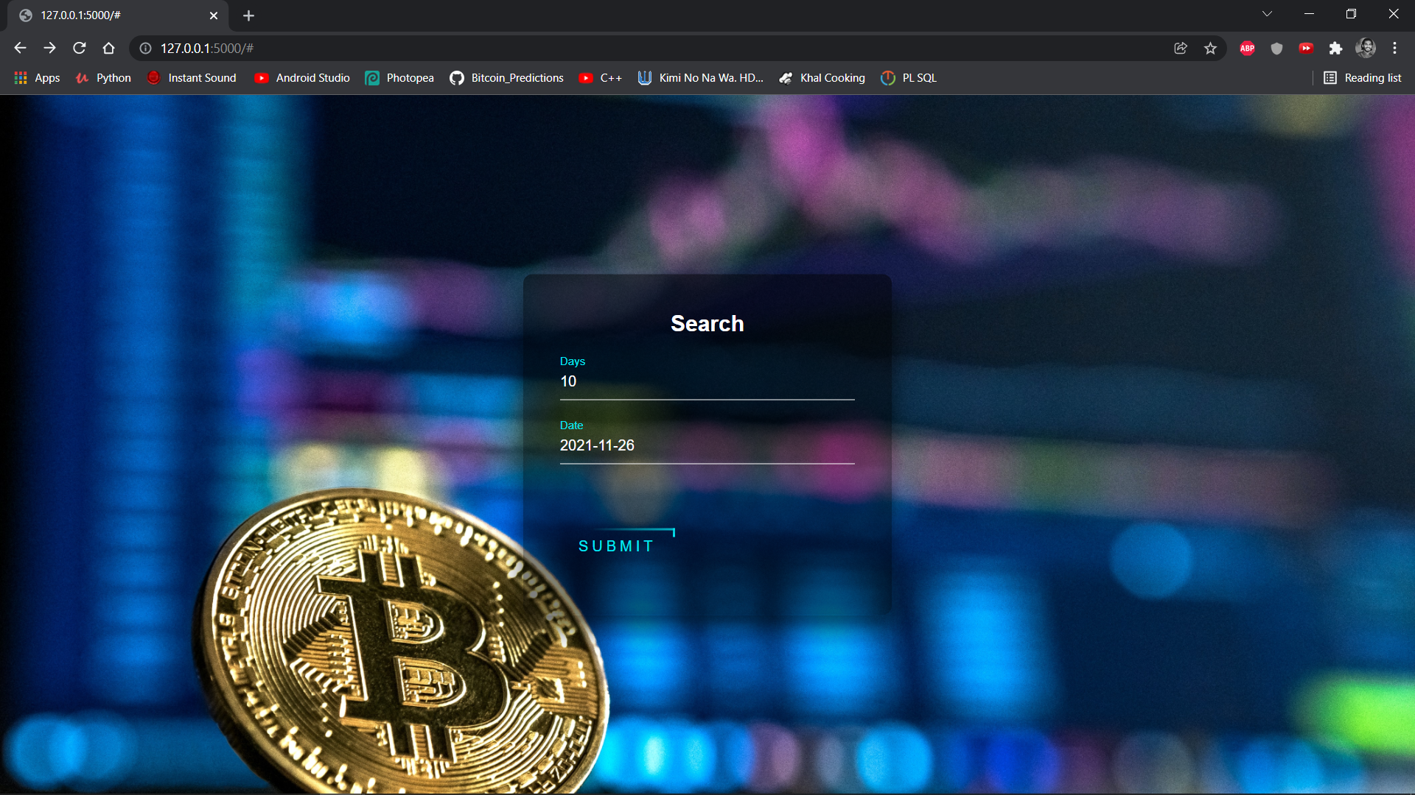

**Fig 31 Result 1**

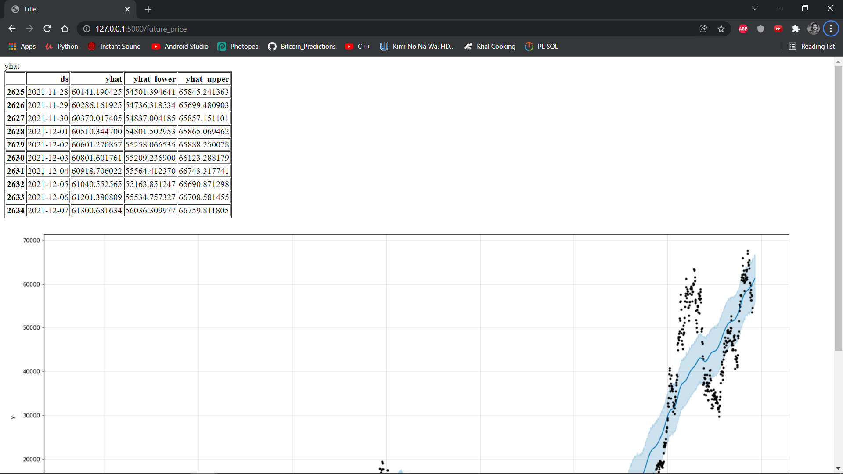

**Fig 32 Result 2**

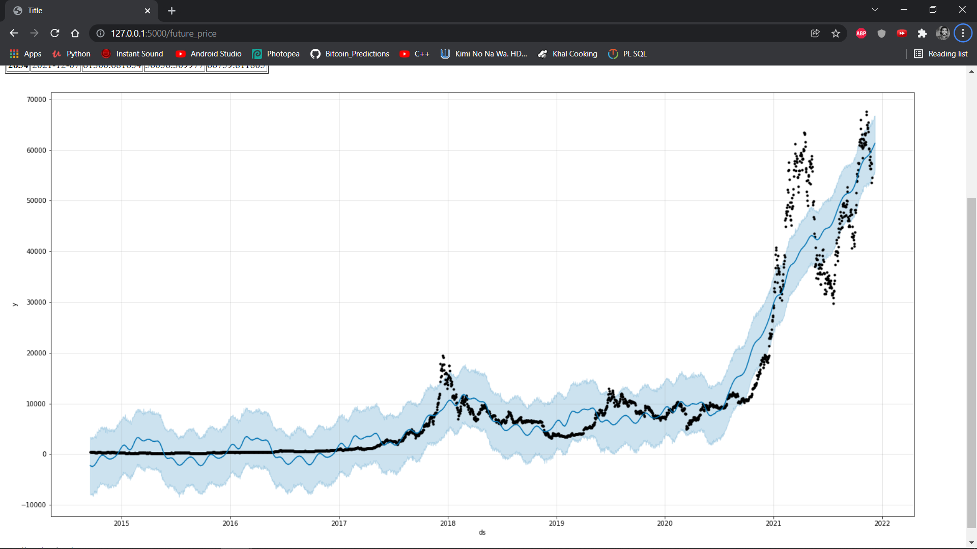

**Fig 33 Result 3**

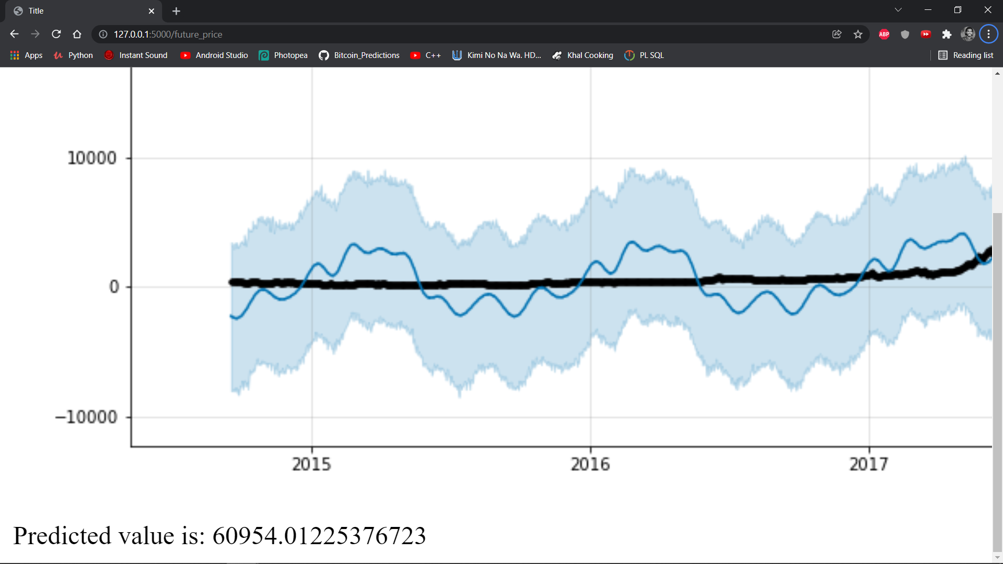

**Fig 34 Result 4**

**9. CONCLUSION AND FUTURE ENHANCEMENT**

**9.1 Conclusion**

The current project can forecast and predict the value of Bitcoin for up to an accuracy of 94% to 95%. Also able to predict the value of a future date and get a predicted value to the user.

**9.2 Future Enhancement**

This project can be extended to obtain the predicted values for various other cryptocurrencies like Etherium(ETH), Dogecoin(DOGE), Ripple(XRP), and many more like the similar way to accept input from the users and plot the predictions.

**10. BIBLIOGRAPHY**

1. Aharon DY, Qadan M (2019) Bitcoin and the day-of-the-week effect. Finance Res Lett 31:415–424
2. Baur DG, Hong K, Lee AD (2018) Bitcoin: medium of exchange or speculative assets? J Int Financ Mark Inst Money 54:177–189
3. Bouoiyour J, Selmi R (2015) What does Bitcoin look like? Ann Econ Finance 16(2):449–492
4. Kathyayini, R. S., Jyothi, D. G. & Crypto, ”. Currency Price Prediction using Machine Learning”. *International Journal of Advanced Research in Computer and Communication Engineering*.
5. Nakamoto, S. & Shah,;. D. (2017). Trading Bitcoin and Online Time Series Prediction. *NIPS 2016 Time Series Workshop*.
6. Santhosh, &., S. G. & ”. A Relative Study on Bitcoin Mining. *Relative Study on Bitcoin Mining”, Imperial Journal of Interdisciplinary Research*.
7. Struga, K. & Qirici, O. Bitcoin Price Prediction with Neural Networks. *Bitcoin Price Prediction with Neural Networks*. Retrieved from http://ceur-ws.org/Vol-2280/paper-06.pdf
8. Garcia, D. & Schweitzer, F. (2015). Social signals and algorithmic trading of Bitcoin. *Royal Society Open Science* 2(9), 150288. Retrieved from https://dx.doi.org/10.1098/rsos.150288 10.1098/rsos.150288
9. Jang, H. & Lee, J. An Empirical Study on Modelling and Prediction of Bitcoin Prices with Bayesian Neural Networks based on Blockchain Information. *An Empirical Study on Modelling and Prediction of Bitcoin Prices with Bayesian Neural Networks based on Blockchain Information*.
10. M. Daniela and A. BUTOI, "Data mining on Romanian stock market using neural networks for price prediction", *informatica Economica*, vol. 17, 2013.
11. F Andrade de Oliveira, L. Enrique ZÃrate, M. de Azevedo Reis and C. Neri Nobre, "The use of artificial neural networks in the analysis and prediction of stock prices", *IEEE International Conference on Systems Man and Cybernetics*, pp. 2151-2155, 2011.
12. D. Shah and K. Zhang, "Bayesian regression and Bitcoin", *52nd Annual Allerton Conference on Communication Control and Computing (Allerton)*, pp. 409-415, 2015.